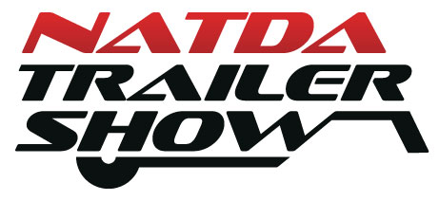
2023 NATDA Trailer Show
Exhibitor Meeting Space Request Form

Exhibiting Company Name: ___________________________________________ Booth #__________

Contact Name: ___________________________ Contact Email: ________________________________

Meeting Date/Time Requested: _________________________________ Number of People: _________
Dealer Meetings will only be approved outside of NATDA scheduled events.

Purpose of Meeting: ___ Sales Team Meeting ___ Dealer Meeting ___Networking Event ___ Other

Room Set Up: ___ Classroom ___ Theater ___ Banquet ___ Reception

Do you need any of the following services? ___ Audio Visual ___ Catering ___ Electric

NATDA will send you the contact information for any of the above-requested services. Any contracts signed for these services, and charges incurred, are the responsibility of the company requesting the meeting.

Special Requests: ________________________________________________________________________

Cost of Meeting Space: $250 for up to a 4-hour meeting.
Payment Method: ___ Credit Card ___ Check
Credit Card # ___________________________ Exp: _________ CCV: __________ Zip Code: ___________

Name on Card:_____________________________ Signature: ___________________________________
If mailing check, please send with copy of form to NATDA, 200 Central Ave, 4th Floor, St Petersburg, FL 33701

I acknowledge that NATDA is providing a conference room ONLY which includes a basic room set. Any additional charges incurred are the responsibility of the company requesting the meeting.

_________________________________________ ________________
Signature Date

_________________________________________
Printed Name

Meeting Approval by NATDA:
Date/Time Confirmed: _________________________________ Room # _______________

Approved by: ________________________________________ Date: __________________

Please return to Andria Gibbon at andria@natda.org. For any questions please call Andria at 727-360-0304 x102.

